Use cooking water to fertilize plants

[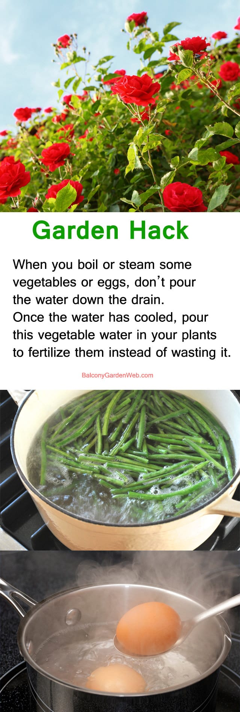](https://balconygardenweb-lhnfx0beomqvnhspx.netdna-ssl.com/wp-content/uploads/2016/06/garden-hack-use-cooking-water.jpg)

When you boil or steam some vegetables on the stove top, don’t pour the water down the drain. Once the water has cooled, pour this vegetable water in your plants to fertilize them instead of wasting it. You can also do the same with your boiled egg water.